🤖

Build a Blog Writer AI Agent

A Vibe Coding Guide for Non-Tech Students

5 Steps  5 Prompts | No Code  Just English | LangGraph  Powered

Tool: Antigravity (Google's AI Coding IDE)

AI PM Cohort | Ashu Mishra

Before You Start — Read This

What is Vibe Coding?

Vibe coding means you describe what you want to build in plain English — and the AI IDE (Antigravity) writes the actual code for you. You are the architect. Antigravity is the builder.

What you will build

A Blog Writer AI Agent using LangGraph. You give it a topic like "Future of AI in Healthcare" — and it automatically plans, writes multiple sections in parallel, and compiles a full blog post. No copy-paste. No manual work.

How to use this guide

Step 1 | Read the 'What's happening here' box first. Understand the idea before you prompt.

Step 2 | Open Antigravity. Start a new project.

Step 3 | Copy the prompt from the grey box and paste it into Antigravity.

Step 4 | Read what Antigravity generates. Don't just run it — understand what appeared.

Step 5 | Check the 'What you should see' list. If something's wrong, describe the problem to Antigravity in plain English.

Structure of the code :
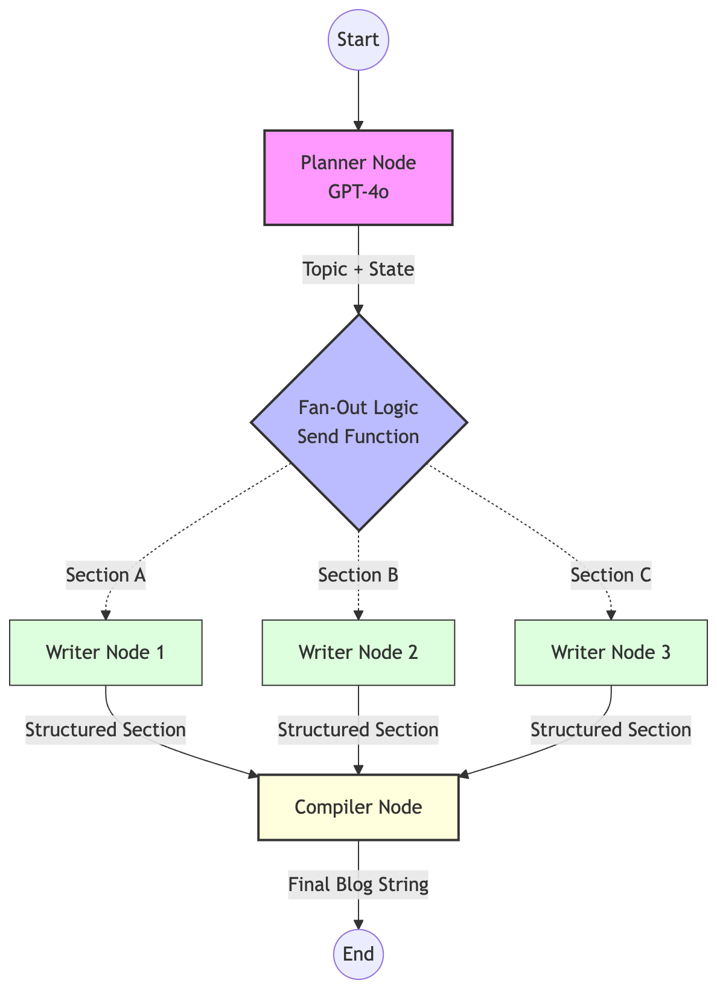

🛠️  STEP 01 | Set Up Your Project  Tell Antigravity to create a new Python project for an AI agent

What's happening here?

Before any cooking can happen, you need a kitchen. This step sets up your project — creating the file, loading the necessary tools (libraries), and connecting your OpenAI API key safely. Think of it like plugging in the appliances before you start cooking.
Key idea: A .env file is a secret vault. It stores your API key so it's never visible in the main code. Antigravity will help you create this automatically.

YOUR PROMPT — Paste this into Antigravity

I want to build an AI Blog Writer Agent using LangGraph and OpenAI in Python.

Please set up a new Python project for me. I need:
- A main Python file called blog_agent.py that is ready to use LangGraph, LangChain with OpenAI, and Pydantic for structured data
- A .env file where I can safely store my OpenAI API key
- All the necessary packages installed so the project is ready to run

I am a beginner. Please explain what each part does after you set it up.

✅ What you should see after this step

- A blog_agent.py file with import statements at the top
- A .env file with a placeholder for OPENAI_API_KEY
- Confirmation that all packages are installed
- A short explanation from Antigravity of what was set up

📋  STEP 02 | Design the Agent's Memory  Define what information the agent tracks while it works

What's happening here?

Every AI agent needs a shared memory — a place where all its mini-workers can read and write information. In LangGraph, this is called State.
Think of it like a shared Google Doc that multiple people are editing at the same time. One person adds the topic, another adds section titles, three people write content simultaneously — and it all appears in the same doc without overwriting each other.
Key idea: The agent needs to track 4 things: (1) the blog topic, (2) the list of sections to write, (3) the completed sections written so far, and (4) the final compiled blog.

YOUR PROMPT — Paste this into Antigravity

Now I need to define the memory structure for my Blog Writer Agent.

The agent needs to remember 4 things while it works:
1. The topic of the blog (a string the user provides)
2. A list of section titles that a planner AI will decide
3. A list of completed written sections — important: multiple AI workers will add to this list at the same time, so it should combine their results rather than overwrite
4. The final compiled blog post as one string

Please also create two small data models using Pydantic: one that represents a list of section titles (for the planner AI to return), and one that represents a written section's content (for the writer AI to return).

Explain what each piece does after you write it.

✅ What you should see after this step

- A BlogState class (TypedDict) with 4 fields
- A SectionState class for individual section workers
- A Sections Pydantic model with a list of section titles
- A SectionContent Pydantic model with a content field

🧠  STEP 03 | Build the Planner Node  The first AI worker — it reads the topic and decides what sections to write

What's happening here?

This is where the AI becomes real. We create our first 'node' — a worker inside the agent. This Planner node's only job is to look at the blog topic and decide: what sections should this blog have?
The key trick here is Structured Output. Normally an AI returns messy text like 'Sure! Here are some sections: Introduction, ...' — which is hard to use in code. With structured output, we force the AI to return a clean Python list. No extra words. Just data.
Think of it like asking a waiter to fill out a form instead of describing the order verbally.

YOUR PROMPT — Paste this into Antigravity

Now create the first AI worker (called a node) for my LangGraph agent. This node is the Planner.

Here is what the Planner should do:
- Receive the blog topic from the shared state
- Use GPT-4o to generate exactly 3 clear section titles for a blog post on that topic
- Return the titles as a clean structured list (not as plain text) — use the Sections Pydantic model we already created for this
- The result should be saved back into the shared state under the 'sections' field

Use a system prompt that tells the AI it is a blog planning expert, and a human message that passes in the blog topic.

Please explain what 'structured output' means and why we are using it here.

✅ What you should see after this step

- A function called generate_sections that takes BlogState
- Usage of llm.with_structured_output(Sections) — not just llm.invoke
- The function returns {'sections': result.sections}
- A comment or explanation about why structured output is useful

⚡  STEP 04 | Add Parallel Writers + The Fan-Out  The magic: multiple AI writers working simultaneously

What's happening here?

This is the most powerful concept in the whole project — parallel execution.
Without this: the agent writes Section 1, waits, then writes Section 2, waits, then writes Section 3. Slow and sequential.
With this: the agent launches all 3 section writers at the exact same time. They all finish together. This is called a Fan-Out pattern.
LangGraph has a special tool called Send() that makes this happen. Instead of saying 'write section 1, then write section 2', you say 'here are 3 tasks — start all of them now.'
Then a Compiler node waits for all of them to finish and stitches everything into one final blog post. This is the Fan-In.

YOUR PROMPT — Paste this into Antigravity

Now add two more nodes to my LangGraph agent and the fan-out logic.

Node 1 — Section Writer:
- This node writes the actual content for ONE section of the blog
- It receives the section title and the blog topic
- It uses GPT-4o with the SectionContent Pydantic model to return structured content
- It should write 2 to 3 good paragraphs per section
- It should format the output as: the section title as a heading, then the content below it
- It saves the result into completed_sections

Node 2 — Blog Compiler:
- This node waits until all section writers are done
- It combines everything in completed_sections into one final blog post with a proper title
- It saves the result into final_blog

Fan-Out Function:
- Write a function that uses LangGraph's Send() feature to launch ALL section writers at the same time, one for each section in the sections list
- This means if there are 3 sections, 3 writers start simultaneously

Please explain the difference between sequential and parallel execution after writing this.

✅ What you should see after this step

- A write_section function for one section at a time
- A compile_blog function that joins completed_sections
- A fan_out_sections function using Send() — one Send per section
- An explanation of parallel vs sequential execution

🚀  STEP 05 | Connect Everything & Run  Wire the graph, compile it, and watch your blog get written

What's happening here?

This is the final assembly step. Think of the previous steps as making individual parts — the engine, the wheels, the frame. Now we bolt them together.
In LangGraph, a graph is a flowchart of workers. You define the arrows — who runs first, who runs next, and who runs in parallel. Once you compile() the graph, LangGraph checks that all the arrows make sense.
Then you invoke() the graph with a topic — and watch it plan, write in parallel, compile, and return a full blog post in seconds.

YOUR PROMPT — Paste this into Antigravity

Now connect all the nodes into a LangGraph graph and run it.

The flow should be:
1. Start → Planner (generate sections)
2. Planner → Fan-Out (launch all section writers in parallel using the fan_out_sections function)
3. All Section Writers → Compiler (once all are done, compile the blog)
4. Compiler → End

Important: the fan-out step needs to use conditional edges in LangGraph because the number of writers changes depending on how many sections were planned.

After building the graph, run it with this topic: "The Future of AI in Healthcare"

Print the final blog clearly in the terminal.

Then explain: what would happen if I change the topic? What would happen if I asked for 5 sections instead of 3? How would I change that?

✅ What you should see after this step

- A StateGraph with all 3 nodes added
- add_conditional_edges used for the fan-out step
- A full blog printed in the terminal — title + 3 sections with content
- Antigravity's explanation of how to change the topic or section count

🎉

You just built a production-style AI agent.

Here is what you actually learned:

🗺️ | State management — how AI agents share memory across tasks
🤖 | Structured outputs — making AI return clean data, not messy text
⚡ | Parallel execution — running multiple AI workers simultaneously (Fan-Out)
🔗 | Graph-based orchestration — connecting agents in a defined flow
🏗️ | Vibe coding — describing what you want and letting AI build it

